**PFP - Labwork 04**

**Question 1 (2 marks): Write a program to perform these tasks:**

1. Turn every item of a list into its square

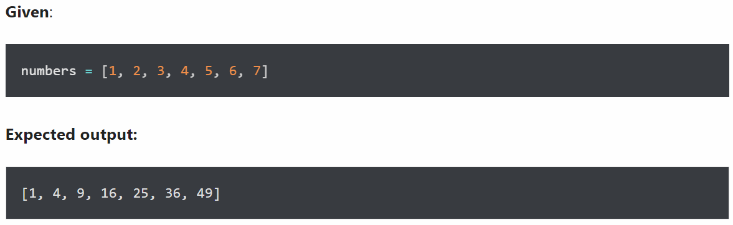

1. Concatenate two lists in the following order

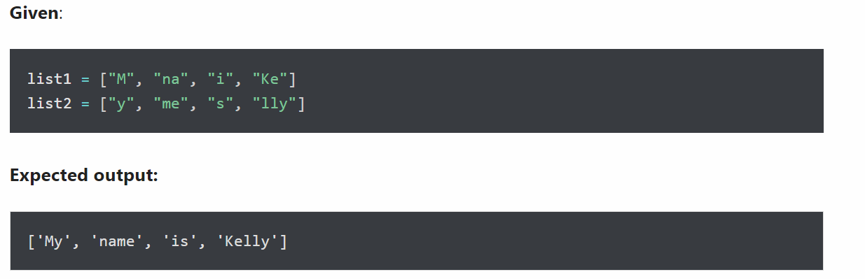

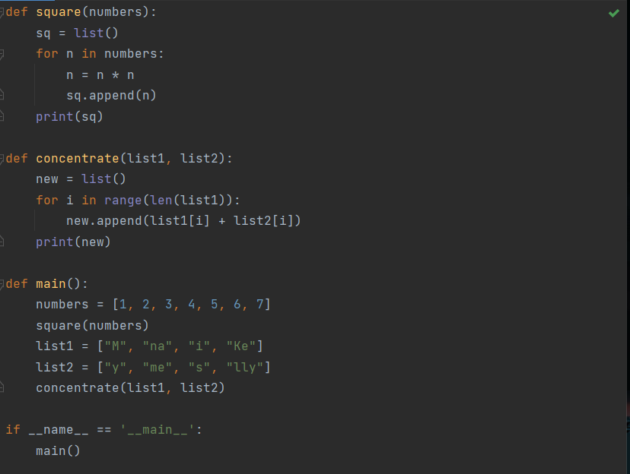

**Question 2 (2 marks): Write a program to perform these tasks:**

Write a program that accepts a string of words entered by the user, separated by commas, and prints the words in alphabetical order, separated by commas.

Example : Input without,hello,bag,world, the output will be: bag,hello,without,world.

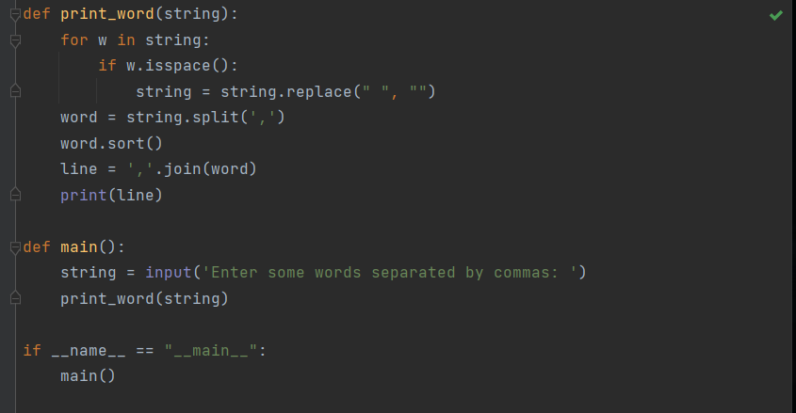

**Question 3 (2 marks): Write a program to perform these tasks:**

A website requires users to enter a username and password to register. Write a program to check the validity of the password entered by the user. If the user enters incorrectly, then notify and ask the user to re-enter.

Password check criteria include:

* At least 2 letter is in [a-z]
* At least 3 number is in [0-9]
* At least 1 character in [A-Z]
* At least 1 character inside [$#@&?]
* Minimum password length: 6
* Maximum password length: 15

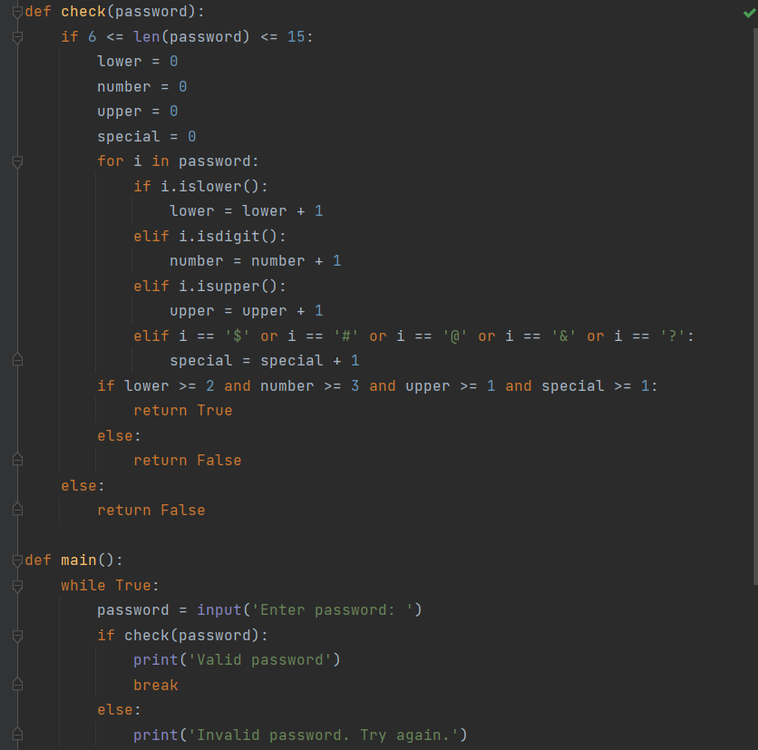

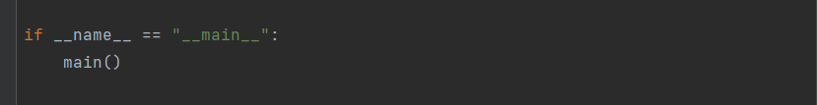

**Question 4 (2 marks): Write a program to perform these tasks:**

Write a program that allows the user to input positive integers until the value 0 is entered. The program prints the numbers entered by the user in ascending order.

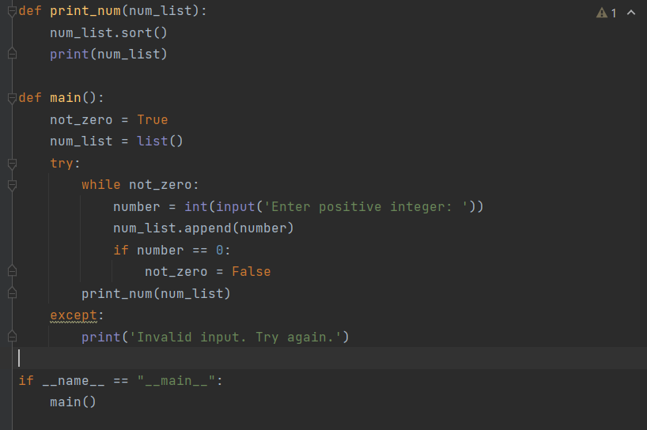

**Question 5 (2 marks): Write a program to perform these tasks:**

Write a program that allows the user to enter the names of n students, then remove the students with the same names and print the results on the screen.

Example : Thanh, Thao, Hung, Huy, Lan, Thao, Tinh, Hung

* Thanh, Thao, Hung, Huy, Lan, Tinh

